Module 2 Summary

Response to feedback
Regarding feedback from Module 1, I’ve rebalanced the learning notes to be less formal and put more emphasis on the actual report, but I’m weary of swinging too far in this direction. Please let me know if the notes are too informal or aren’t really on-point. I’ve restructured the report to be modular so that it’s easier to address all def/theory, and I approached all the concepts more directly, but wondering if I need to be more direct with individual definition rules in the report, or if I’ve written too summarily in any case. Next I’ll work on streamlining my notes and documentation so I can reference them better in my report. Many thanks in advance!

Module Learning Objectives
I certify that I achieved the following learning objectives for the module:
- Perform basic operations on matrices
- Calculate products of matrices and identify when the operation is valid
- Interpret matrices and operations in context

Key Definitions and Theorems
Matrix addition, scalar multiplication and transpose
Textbook Ref | Theorem/Definition statement | Learning Notes
Definition 2.1  Matrix Addition | If A and B are matrices of the same size, their sum A+B is the matrix formed by adding corresponding entries, i.e. for the entries a_{ij} and b_{ij} in A and B, the entry in the matrix A+B will be a_{ij} + b_{ij} | Matrices have to be matching dimensions for addition, no method for addition of non-equal matrices
Definition 2.2 Matrix Scalar Multiplication | If A is any matrix and k is any number, the scalar multiple kA is the matrix obtained from A by multiplying each entry of A by k, i.e. ka_{ij} for all entries. | This is the most basic linear scaling of systems, any real number scaling the system up or down
Theorem 2.1.1 Properties of matrix addition and multiplication by a scalar | Let A, B, and C denote arbitrary m×n matrices where m and n are fixed. Let k and p denote arbitrary real numbers. Then  1. A+B = B+A  2. A+(B+C) = (A+B)+C  3. There is an m×n matrix 0, such that 0+A = A for each A  4. For each A there is an m×n matrix, −A, such that A+(−A) = 0  5. k(A+B) = kA+kB  6. (k+ p)A = kA+ pA  7. (kp)A = k(pA)  8. 1A = A | 1. commutativity  2. associativity  3. additive identity element  4. additive inverse  5. distributivity for scalar times sum of two matrices  6. distributivity for sum of two scalars times a matrix  7. associativity with scalars  8. multiplicative scalar identity element  Overall it’s relatively similar to normal int addition, note that introducing scalars is flexible but keep the same order for matrices
Definition 2.3 Transpose of a matrix | If A is an m×n matrix, the transpose of A, written A^{T}, is the n×m matrix whose rows are just the columns of A in the same order. | We make the rows columns, and the columns rows, the transpose always exists for any m*n matrix  Note, maintain the order of col/row appearance
Theorem 2.1.2 Properties of transpose | Let A and B denote matrices of the same size, and let k denote a scalar.  1. If A is an m×n matrix, then A^{T} is an n×m matrix.  2. (A^{T} )^{T} = A.  3. (kA)^{T} = kA^{T}.  4. (A+B)^{T} = A^{T} +B^{T}. | Note, double-transpose cancels itself out, and T only applies to matrices, so it distributes over matrix addition but doesn’t interact with scalars

Matrix-vector multiplication
Textbook Ref | Theorem/Definition statement | Notes
Definition 2.4 The set ℝ^{n} | Let ℝ denote the set of all real numbers. The set of all ordered n-tuples from ℝ is denoted by ℝ^{n} | Finite sets of ordered numbers in the R^n set, this is our solution space
Definition 2.5  Matrix-vector multiplication | Let be an m×n matrix, written in terms of its columns . If is any n-vector (i.e., x  ℝ^{n}), the product Ax is defined to be the m-vector in ℝ^{m} given by: | Single pass, all rows of A through one tuple as opposed to corresponding columns for matrix-matrix
Theorem 2.2.2 Properties of matrix-vector multiplication | Let A and B be m×n matrices, and let x and y be n-vectors in ℝ^{n}. Then:  1. A(x+y) = Ax+Ay.  2. A(ax) = a(Ax) = (aA)x for all scalars a.  3. (A+B)x = Ax+Bx. | Always respect the original order of matrix/vector multiplication, but scalars have much more flexibility in terms of reordering
Definition 2.6 Dot product in ℝ^{n} | If (a₁,a₂,…,a_{n}) and (b₁,b₂,…,b_{n}) are two ordered n-tuples in ℝ^{n}, their dot product is defined to be the number  a₁ b₁ + a₂ b₂ +… + a_{n} b_{n}  Obtained by multiplying corresponding entries and adding the results. | Multiplying two n-tuples leads to a single dot product, matrix multiplication is iteratively multiplying vectors, so it builds off of this definition
Theorem 2.2.3 General solution for non-homogenous systems | Suppose x₁ is any particular solution to the system Ax = b of linear equations. Then every solution x₂ to Ax = b has the form  x₂ = x₀ + x₁  for some solution x₀ of the associated homogeneous system Ax =0. | Callback to solutions of systems being a combo, of a particular solution and a solution to the corresponding homogeneous system
Theorem 2.2.4 Relationship between rank of augmented matrix and consistency | Let Ax = b be a system of equations with augmented matrix [A | b ]. Let rank A = r.  1. rank [A | b ] is either r or r + 1  2. The system is consistent if and only if  rank [A | b ] = r  3. The system is inconsistent if and only if rank  rank [A | b ] = r + 1 | REMEMBER to maintain the distinction of A from A | b, the rank difference between each is what provides the earliest insight for the solution
Theorem 2.2.5 Dot product rule | Let A be an m×n matrix and let x be an n-vector in ℝ^{n}. Then each entry of the vector Ax is the dot product of the corresponding row of A with x. | We perform matrix-vector multiplication through dot products  Note, multiplying by a compatible column-vector will return a column-vector, n-directional
Theorem 2.2.6  Uniqueness of matrix-vector multiple | Let A and B be m×n matrices. If Ax = Bx for all x in ℝ^{n}, then A = B. | Matrix-vector behaviour is order-specific, so they must be equal, each combo is unique
Definition 2.8 Matrix Transformation T_{A} | T_{A} is called the matrix transformation induced by A, with T_{A} : ℝ^{n} → ℝ^{m} defined by T_{A} (x) = Ax for every x in ℝ^{n} | Matrix transformations are like functions for performing operations, we refer to the multiplication-effects of a matrix this way

Matrix multiplication
Textbook Ref | Theorem/Definition statement | Notes
Definition 2.9 Matrix Multiplication | Let A be an m×n matrix, let be an n×k matrix, where is column j of B for each j. The product matrix AB is the m×k matrix defined as follows: | Matrix multiplication works even if B isn’t n * m, only the A col value needs to match the B row value, but the other 2 can be completely different
Theorem 2.3.1  Associativity with matrix-matrix-vector multiplication | Let A be an m×n matrix and let B be an n×k matrix. Then the product matrix AB is m×k and satisfies  A(Bx) = (AB)x for all x in ℝ^{k} | Matrices and vectors are treated similarly when grouping, it’s multiplying sets, order must be maintained
Theorem 2.3.2 Dot Product Rule for matrix-matrix multiplication | Let A and B be matrices of sizes m×n and n×k, respectively. Then the (i, j)-entry of AB is the dot product of row i of A with column j of B. | Referencing cells by their row-column location, like 2D arrays, as row-column dot products
Theorem 2.3.3 Properties of matrix-matrix multiplication | Assume that a is any scalar, and that A, B, and C are matrices of sizes such that the indicated matrix products are defined and I is an identity matrix.  Then:  1. IA = A and AI = A  2. A(BC) = (AB)C.  3. A(B+C) = AB+AC.  4. (B+C)A = BA+CA.  5. a(AB) = (aA)B = A(aB).  6. (AB)^{T} = B^{T}A^{T} | Largely unchanged from their traditional counterparts, ALWAYS the order must be maintained  Note, I is flexible  Note, distributing T inverts the mult order

MODULE 2
Module 2 covers the behaviour of matrix arithmetic, outlining how algebraic rules like associativity and distributivity etc., interact with matrix addition, scaling, and transposition. Working first through matrix addition, the module akes building-blocks from vector multiplication of n-tuples in the set ℝ^{n} and applies this theory iteratively over matrix-vector multiplication and matrix-matrix multiplication. Compatible behaviour for maintaining linearity is thoroughly explored with each concept.
2.1 – Matrix Addition, Scalar Multiplication, Transposes
Addition, scalar multiplication, and transposition are the basic operations we can perform between Matrices. We can add two matrices together, scale a matrix linearly, or flip one over its diagonal (transpose). Matrix arithmetic lets us manipulate systems consistently to achieve the desired outcome while maintaining the system properties/behaviour.
2.1 Definitions
Matrix addition requires adding corresponding entries from two matrices of the same size/dimensions. This means that if A and B are both m*n matrices, they can be added by summing each (i, j)th entry from A and B to return the resulting matrix, where i and j are row/column entries. This is dictated by Definition 2.1, where all entries aij and bij of A and B added together, output the final A + B matrix. The compatible behaviour is unpacked further down in Theorem 2.1.1.
Scalar multiplication, as per Definition 2.2, scales each cell linearly. This means that a matrix can be multiplied by a scalar k to return the matrix as a linear product of k. The scalar applies the same to every entry of A, resulting in a kA matrix.
Transposition flips the matrix over its diagonal (top left to botton right middle), resulting in the matrix having its m and n dimensions swapped. As with Definition 2.3, the transpose of m*n matrix A presents a new matrix A^T, which is an n*m matrix.
2.1 Theory
Theorem 2.1.1 and Theorem 2.1.2 dictate the behaviour of transposition, scalar multiplication and matrix addition:
Properties of matrix addition and scalar multiplication
Theorem 2.1.1 highlights the existence of commutativity, associativity, and an additive identity referred to as the zero matrix. This shows that matrix addition behaves similarly to traditional addition, and each matrix A can be presented as a negative (additive identity, -A) or a positive (A). Given the additive identity, adding this to the original matrix A will result in 0, since each corresponding entry of A will be added with its negative. Distributivity and associativity are compatible when multiplying matrices and scalars, but the order in which matrices are multiplied must remain the same.
Theorem 2.1.2 determines how transposition behaves in respect to matrix addition and scalar multiplication. Transposition of a transposed matrix returns the original matrix, and transposition does not apply to scalars (only matrices). ^T notation behaves similarly to exponents when grouping/expanding with matrix addition, e.g., (A+B)^{T} = A^{T} + B^{T}.
2.2 – Matrix-Vector Multiplication
Matrices can be applied to compatible vectors through multiplication. This returns a new vector of dot products, sums of each row’s entries multiplied by their corresponding value in the vector x. As per the rules of linear scaling, this multiplication behaves linearly and respects the original system with linear addition and multiplication.
2.2 Definitions
Matrix-vector multiplication is described in Definition 2.5, the behaviour of multiplying a matrix A by vector x. Each dot product is obtained by multiplying each row of A through vector x, resulting in a dot product vector. Multiplying a matrix by a column vector (n-vector), will return a row vector, the size of the matrix-rows value. Multiplying by a row vector (m-vector), will return a column vector, the size of the matrix-columns value. This is expressed in Theorem 2.2.5 as Ax, a resulting vector of dot products.
Definition 2.4 covers the domain of all real n-tuples, ordered sets of only real numbers. All real n-tuples exist in the set ℝ^{n} . Definition 2.6 applies the dot product concept to vector * vector multiplication. All dot products of compatible m and n vectors in ℝ^{n} result in a single value, equal to a₁ b₁ + a₂ b₂ +… + a_{n} b_{n}. This is a building-block for matrix multiplication.
2.2 Theory
Summarily, Theorem 2.2.2 highlights the linearity of matrix-vector multiplication, and how it behaves when performed with sums-of-vectors, products of vectors, and sums of matrices. Like all previous scenarios. the order of matrix and vector appearance needs to be maintained when rearranging the expression.
Theorem 2.2.3 provides a call-back to the previous module, building upon how general solutions to non-homogeneous systems are combinations of a particular solution, and a solution to the corresponding homogeneous system. This reinforces that all solutions for a non-homogeneous system Ax = b with regards to Ax = 0 can be expressed as x₂ = x₀ + x₁ (where x₂ is every solution to Ax = b). Remembering that homogeneous systems always contain the trivial solution, with a basic system as an example:
x₁ + 2x₂ = 3
2x₁ + 4x₂ = 6
Equation 2 is double equation 1, so if we opt for x₂ = 0, then x₁ = 3, giving the particular solution: [ 3 ]
[ 0 ]
When all the constant terms are 0 (Ax = 0), then we find x₁ = -2x₂, true for 0 in line 1. Expressed as the general solution where x₂ = t: t [ -2 ]
[ 1 ]
The rank of augmented matrices is discussed in Theorem 2.2.4, which links the consistency of a linear system to one of three rules. This module puts emphasis on distinguishing the rank of A from the rank of A | b, the augmented equivalent. These are two separate matrices and their rank difference implies the nature and existence of solutions (whether rank of A | b is the same or one greater than A).
The x₂ = x₀ + x₁ expression is therefore [ 3 ] + [ -2 ] for any real t
[ 0 ] t [ 1 ]
Passing any real value for t, e.g., 1, we get the matrix [ 3 – 2 ] which is [ 1 ]
[ 0 + 1 ][ 1 ]

Passing 1 for each x₁ and x₂ holds true for equations 1 and 2, and holds the same for any real number, proving that the combination [ 3 ] + [ -2 ] is our particular solution
[ 0 ] t [ 1 ]

Theorem 2.2.6 ties back to the order of matrices and vectors in multiplication, and what can be inferred about some matrix B, if for some matrix A, Ax = Bx (where x is any vector). This reinforces the idea of every matrix containing unique properties and behaviour, and that all matrix-vector multiples are themselves unique. Definition 2.8 describes Ax through the scope of T_{A ,}being a transformation. When A is applied to x through multiplication, the effect induced on x by A is defined as T_{A} (x) = Ax.
2.3 – Matrix Multiplication
Expanding on Matrix-Vector multiplication, a Matrix can be applied to another matrix through multiplication. The order of matrix multiplication is extremely important, since matrices AB, when multiplied in that order, does not return the sane as BA. The process permits distribution and scaling. It’s associative when reordering bracket-grouping logic, but the order MUST BE MAINTAINED.
Matrix multiplication can be approached in 3 different ways:
A collection of dot products, sums of products taken from corresponding row-column entries
Mixing of rows, where each result in C is a combination of the rows of B scaled by corresponding entries in rows of A
Mixing of columns, each result in C is a combination of the columns of B scaled by corresponding entries in columns of A
2.3 Definitions
Definition 2.9 takes the building-block from Definition 2.6 and establishes the order of matrix * matrix multiplication, determined by dot products of iteratively multiplying rows of matrix A through corresponding columns of matrix B.
2.3 Theory
Associativity behaviour with matrix-matrix-vector multiplication is described by Theorem 2.3.1. Grouping differently will not change the result so long as the order of matrices and vector multiplication is maintained.
Theorem 2.3.2 builds upon Definitions 2.6, 2.9, by addressing the dot-product rule of matrix-matrix multiplication. For every entry (i, j) in AB, the dot product is taken by multiplying through corresponding rows and columns, collectively performing individual vector * vector multiplication in order.
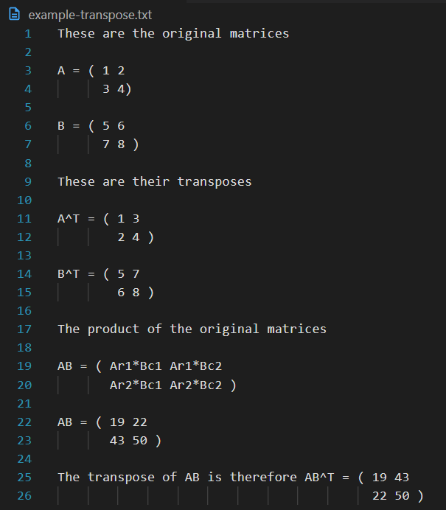
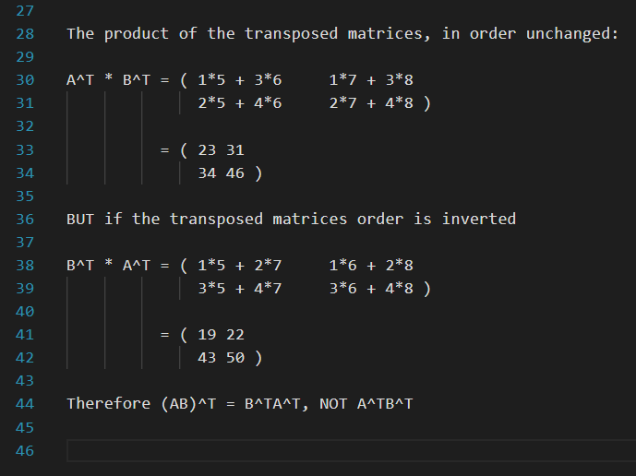
Theorem 2.3.3 introduces the unique properties of the Identity matrix, the matrix-equivalent of scalar 1, in matrix-matrix multiplication. Although I is treated as representative of 1, Identity matrices have a range of unique properties in their own right. Rules 2 – 4 describe the behaviour of associativity, distributivity over matrix sums, and compatibility when including a scalar with matrix-matrix multiplication. As always, order is key to maintaining the original system. The transpose property over a matrix-matrix multiplication inverts this order, so transposition of a product matrix (AB)^{T} is equal to B^{T}A^{T} . Take two matrices for example:

Summarily, Module 2 unpacks the concepts necessary for different variations of matrix and vector addition/multiplication scenarios. It applies the algebraic rules to determine compatible operations on linear systems subject to additive and scalar operations. Linearity is maintained through the appearance order of matrices and vectors to ensure the multiplication is equal when rearranging how it’s expressed. The focus of matrix-vector multiplication as a function that transforms the vector, with changes induced by the matrix A, provides a new tool for describing a system’s effects through multiplication. This lightly introduces the next module, where matrix transformations will be explored as operations. The Identity is introduced in this module to represent the scalar 1 in matrix form, and the transpose is introduced as a unique tool for flipping matrix entries across the diagonal. Their relevant behaviours show that transposition is capable of inverting the order of multiplication when applied over a product of matrices. Altogether, this module encapsulates the valid fundamental arithmetic which can be performed between scalars, vectors, and matrices.

Reflecting on the content:
I’ve had lots of practise with matrix multiplication in the past, so it was nice to unpack all the underlying theory for this topic. I find matrix multiplication quite intuitive, so I didn’t have too much trouble with the problems here. I instead put more focus on the report which I think turned out much better this time. Overall, very comfortable with how I progressed through this topic.

References

Report and Notes
[1] D. Burzynski, “Matrix Multiplication,” LibreTexts. [Online].
Available: https://math.libretexts.org/Bookshelves/Applied_Mathematics/Mathematics_for_Game_Developers_(Burzynski)/04%3A_Matrices/4.03%3A_Matrix_Multiplication.
Accessed: 22/07/2025.

[2] K. Kuttler “Multiplication of Matrices,” LibreTexts. [Online].
Available: https://math.libretexts.org/Courses/Mission_College/MAT_04C_Linear_Algebra_(Kravets)/02%3A_Matrices/2.02%3A_Multiplication_of_Matrices.
Accessed: 22/07/2025.

Work Verification
[3] Apple Inc., “Calculator Infinity,” App Store. [Online].
Available: https://apps.apple.com/us/app/calculator/id458535809.
Accessed: 22/07/2025.

